NAME:- KISHORE KUMAR DC

ASSINGMENT-02

**DATASET PREPARATIONAND FEATURE EXTRACTION FOR THE WATER QUALITY ANALYSIS**

* **PREPARE THE 500 SAMPLES OF WATER DATA WITH REQUIRED MINERALS**

**I was saved 500 samples of water data with required minerals in excel csv file format.**

**‘500 samples.csv’**



**You can see the 500 samples on double clicking on above table**

* Data cleaning operations with pandas (python)

1. **This code is used in pandas to view your csv file import pandas as pd**

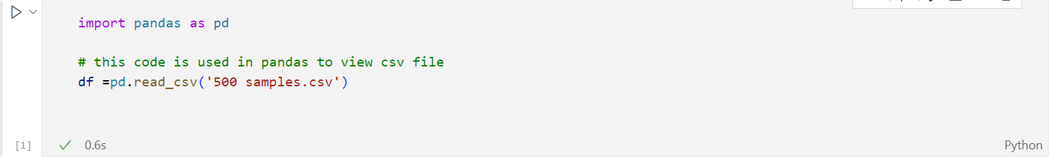

1. **This code will used to find all the null values (pandas consider null values as NaN )**

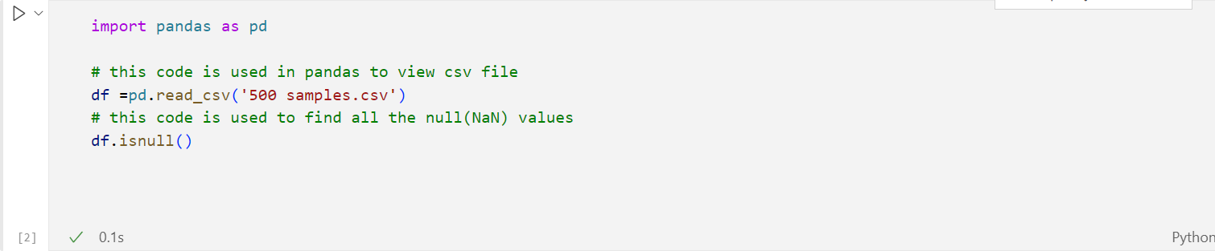

1. **This code will find non applicable (empty data) and remove it new_df = df.dropna()**

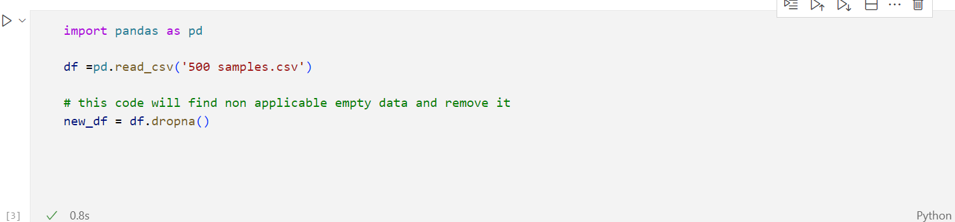

1. **This code will find empty cells in your csv file**

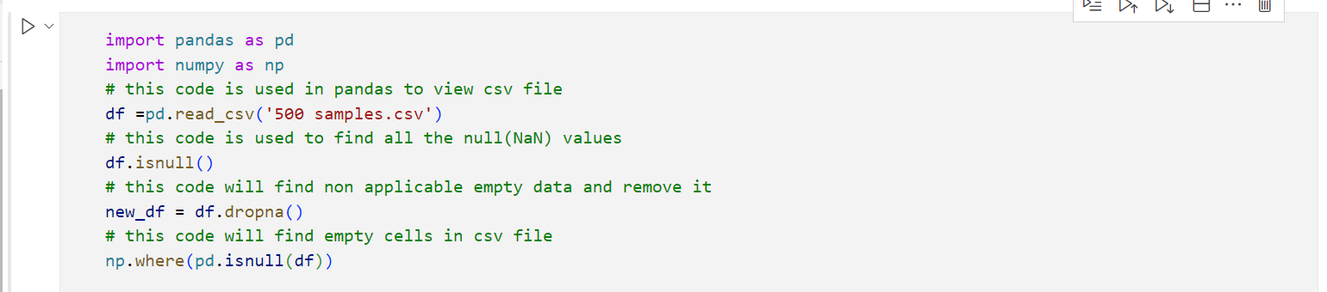

1. **This code will replace NaN values with the nearest minimum value**

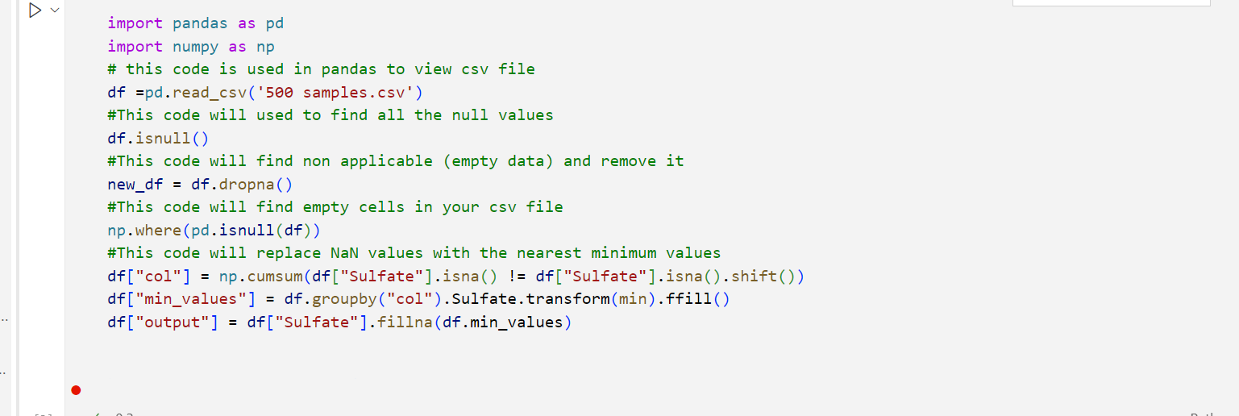

1. **replace Nan values with mean**

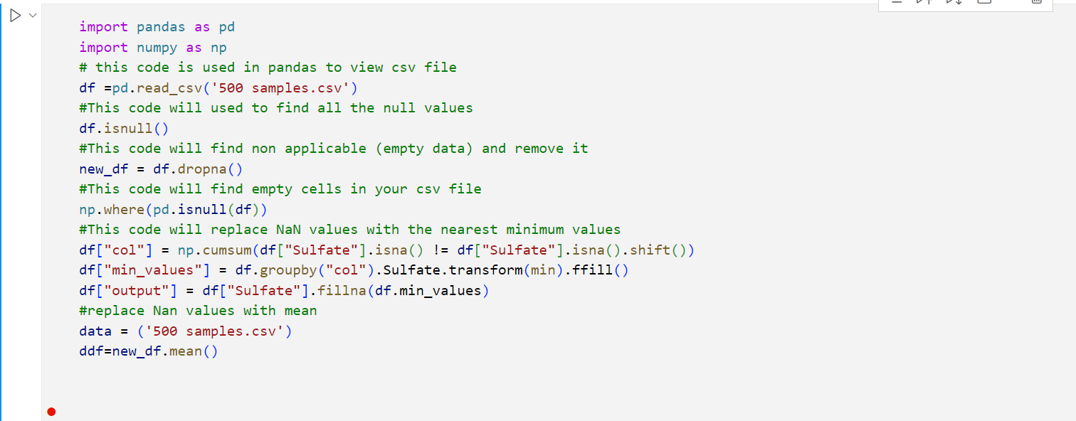

1. **Remove rows with empty columns**

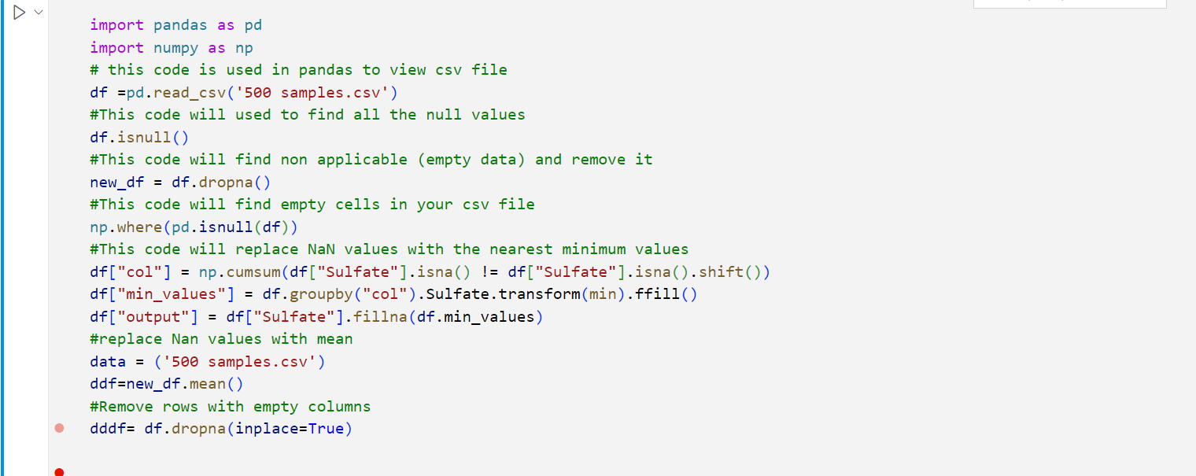

**FULL IMPLEMENTED**

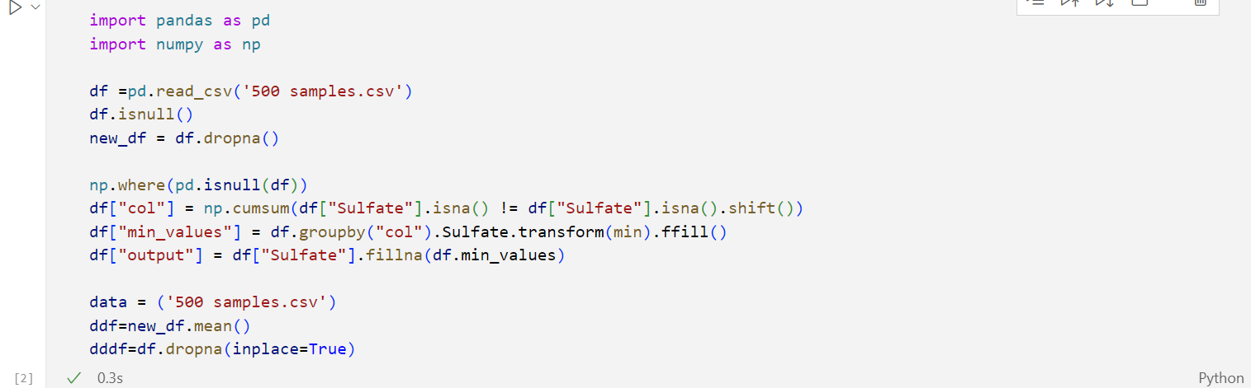

**OUTPUT**

